

DIVISION OF COMPUTER SCIENCE AND ENGINEERING

SCHOOL OF COMPUTER SCIENCE AND TECHNOLOGY

A PROJECT BASED EVALUATION REPORT

SUBMITTED BY
BLESSY FLORIDA(URK24CS1121)

COURSE CODE
23CS2022

COURSE NAME
INTERNET OF THINGS

OCTOBER 2025

INDUSTRIAL CERTIFICATION



IOT- ENABLED SAFETY DEVICE

PROJECT REPORT

Submitted by
AMIRTA VASANTHA V S (URK24CS1056)
JERUSA PEARLIN G (URK24CS1058)



DIVISION OF COMPUTER SCIENCE AND ENGINEERING

KARUNYA INSTITUTE OF TECHNOLOGY AND SCIENCES (Declared as Deemed-to-be-under Sec-3 of the UGC Act, 1956) Karunya Nagar, Coimbatore - 641 114. INDIA
OCTOBER 2025.

ABSTRACT

Brief Summary of the Project
This project proposes the design and implementation of a compact, hidden IoT-based safety device aimed at enhancing personal security during kidnapping incidents. The device is engineered to discreetly notify law enforcement and guardians in real time, leveraging location-based alerts and embedded system technologies. It is particularly tailored for vulnerable groups such as women and children, offering a proactive solution to rising safety concerns.

Objectives and Scope of the Project
- Primary Objective:
To develop a concealed IoT - enabled emergency alert system that can automatically notify police and guardians during kidnapping or abduction scenarios.
- Scope:
  - Focuses on real-time communication and location tracking using IoT protocols.
  - Designed for integration into personal belongings (e.g., children's school bags, women's accessories).
  - Promotes awareness of public safety technologies and encourages hands-on learning in embedded systems and smart device design.
  - Addresses social impact by prioritizing marginalized and high-risk groups.

Key Features and Functionalities
- Emergency Call Trigger
- Real-Time Location Sharing
- Discreet Design
- Multi-User Notification
- Smart Integration

CHAPTER 1
INTRODUCTION

  - BACKGROUND INFORMATION ABOUT THE PROJECT


Kidnapping and abduction incidents have become increasingly alarming in recent years, especially affecting vulnerable populations such as women and children. Traditional safety measures often rely on visible devices or manual intervention, which may not be feasible during high-risk situations. In such cases, the need for discreet, automated, and real-time safety solutions becomes critical.
The rapid advancement of Internet of Things (IoT) technologies offers a promising pathway to address these challenges. IoT enables smart, connected devices to communicate and respond autonomously, making it ideal for emergency alert systems. By integrating sensors, GPS modules, and communication protocols, IoT-based safety devices can detect threats and trigger alerts without requiring active user input.
This project builds on the concept of embedded intelligence and proactive safety, aiming to design a hidden IoT-enabled device that can silently notify police and guardians during kidnapping scenarios. The device is intended to be compact and easily concealable within personal belongings, such as school bags or handbags, ensuring it remains undetected by perpetrators while still functioning effectively.
Beyond its technical innovation, the project also contributes to social awareness and educational development. It encourages hands-on learning in embedded systems, promotes public safety consciousness, and supports the development of scalable solutions for marginalized communities. By combining technology with social impact, the project aligns with broader goals of inclusive security and responsive emergency infrastructure.

  - PROBLEM STATEMENT AND MOTIVATION
Kidnapping and abduction—especially involving women and children—remain pressing safety concerns in many regions, often occurring in situations where victims are unable to access conventional communication tools like mobile phones or panic buttons. Existing safety solutions are frequently visible, easily detectable, or require manual activation, making them ineffective in high-risk scenarios. This project is motivated by the urgent need to develop a concealed, intelligent, and autonomous IoT-based safety device that can silently trigger emergency alerts and share real-time location data without requiring direct user interaction. By integrating embedded systems and IoT technologies, the device aims to enhance emergency response speed, ensure discreet protection, and empower vulnerable individuals with smart, proactive safety tools.

  - OVERVIEW OF THE CONCEPTS USED
The development of this hidden IoT-based safety device draws upon a blend of advanced concepts from Internet of Things (IoT), embedded systems, wireless communication, and safety engineering. At its core, the project utilizes IoT technology to enable real-time data exchange between the device and external entities such as police servers or guardian smartphones. This connectivity ensures that emergency alerts and location data can be transmitted instantly during a kidnapping scenario. Embedded systems play a crucial role in managing the device’s internal operations, with microcontrollers programmed to process sensor inputs and autonomously trigger alerts without requiring manual intervention. Wireless communication protocols such as GSM and GPS are integrated to facilitate both location tracking and message transmission, allowing responders to pinpoint the victim’s whereabouts and act swiftly. The device also incorporates location-based services (LBS) to enhance the precision of geolocation data shared during emergencies. From a design perspective, the project emphasizes concealment and tamper resistance, ensuring the device remains undetected while functioning reliably under stress. Beyond its technical foundation, the project promotes educational engagement by encouraging hands-on learning in electronics, coding, and system integration. It also highlights the social relevance of technology in safeguarding marginalized communities, making it not only a technical innovation but also a meaningful contribution to public safety and awareness.

CHAPTER 2
LITERATURE REVIEW

2.1 REVIEW OF RELEVANT LITERATURE, CONCEPTS, AND TECHNOLOGIES USED IN THE PROJECT
The increasing prevalence of kidnapping and abduction cases—especially among children and women—has prompted researchers and technologists to explore smart safety solutions. Several studies and prototypes have demonstrated the potential of IoT and embedded systems in developing real-time alert mechanisms. For instance, the paper “IoT and GSM Based Child Abduction Rescue Device” by Rabiathul Fathima et al.
From a conceptual standpoint, this project builds on the foundation of Internet of Things (IoT), which enables devices to communicate over networks and respond autonomously. IoT facilitates real-time data transmission, remote monitoring, and integration with mobile platforms.
Wireless communication technologies like GSM and GPS are critical for sending alerts and tracking location. GSM modules enable SMS or call-based notifications, while GPS modules provide accurate geolocation data. Some advanced systems also explore LoRa or Wi-Fi for extended range and connectivity. The use of location-based services (LBS) further enhances the precision of emergency responses by embedding real-time coordinates in alert messages

2.2 COMPARISON WITH SIMILAR PROJECTS OR EXISTING SOLUTIONS

Several existing safety devices and research prototypes have attempted to address personal security concerns using IoT and embedded technologies. However, this project distinguishes itself through its focus on concealment, autonomous operation, and real-time multi-stakeholder alerting, especially tailored for high-risk groups like women and children.
In contrast, the proposed device in this project is designed to be hidden within everyday items like school bags or handbags, making it less detectable. It emphasizes autonomous triggering mechanisms, potentially using sensors or voice commands, to initiate alerts without requiring conscious user input. Additionally, it supports simultaneous notification to police and guardians, enhancing the speed and coordination of emergency response.
Furthermore, while many existing solutions focus solely on technical functionality, this project integrates educational and social dimensions—encouraging hands-on learning in embedded systems and raising awareness about safety technologies in underserved communities.
CHAPTER 3
SYSTEM DESIGN
3.1 ARCHITECTURE AND HIGH-LEVEL DESIGN OF THE SYSTEM
- Sensing and Control Layer (Device Level):
This layer includes the embedded hardware components such as a microcontroller, GPS module, GSM module, and activation sensors. The microcontroller continuously monitors the input from these sensors.
- Communication Layer (Network Level):
Once triggered, the device uses the GSM module to send SMS or call alerts to predefined contacts, including police and guardians.
- Response and Monitoring Layer (User Interface Level):
On the receiving end, guardians or authorities receive the alert via SMS or call, including the victim’s location interaction, visualization, and decision-making.
High-Level Design Flow
- Idle Monitoring Mode
- Trigger Detection
Key Design Considerations
- Concealment: The device is compact and designed to be hidden in personal items like bags or clothing.
- Autonomy: Operates independently without requiring smartphone pairing or manual navigation.
3.2 BLOCK DIAGRAMS (ARCHITECTURE DIAGRAM, FLOW DIAGRAM, ETC.)
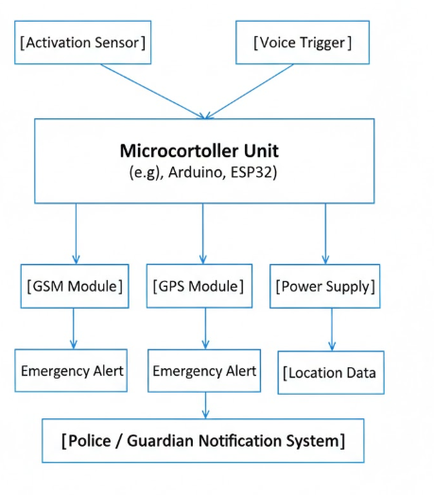

Figure 3,2(a): Architecture
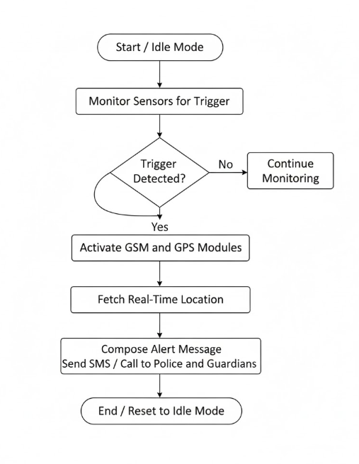

Figure 3.2(b): Flow diagram

3.3 DESCRIPTION OF THE PRODUCT WORKFLOW WITH NECESSARY DIAGRAM
- Trigger Detection:
When a threat is sensed—either through a physical press, voice command, or abnormal movement—the microcontroller interprets the input and initiates the emergency protocol.
- Module Activation:
The GSM and GPS modules are activated. The GPS module fetches the current location coordinates, while the GSM module prepares to send alerts.
- Alert Transmission:
The message is sent via SMS or call to multiple stakeholders, including police authorities and guardians.
- Optional Tracking Interface:
If integrated with a mobile app or dashboard.
- Reset or Continuous Monitoring:
After alert transmission, the system either resets to standby mode or continues monitoring based on configuration.
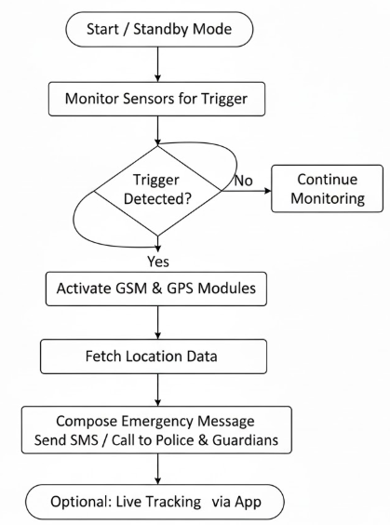

Figure 3.3(a): Workflow diagram

CHAPTER 4
IMPLEMENTATION

4.1 DETAILED EXPLANATION OF THE IMPLEMENTATION PROCESS
1. Requirement Analysis and Design Planning
The project begins with identifying the core requirements: discreet form factor, autonomous alert triggering, real-time location tracking, and multi-stakeholder notification. Based on these needs, the system architecture is designed to include a microcontroller, GPS module, GSM module, activation sensors, and a power supply. The device is intended to be compact enough to fit inside personal items like school bags or handbags.
2. Hardware Selection and Assembly
- Microcontroller: An ESP32 or Arduino Nano is chosen for its low power consumption and sufficient I/O capabilities.
- GPS Module: Used to fetch real-time location data (e.g., Neo-6M).
- GSM Module: Enables SMS or call-based alert transmission (e.g., SIM800L).
- Sensors: A push button, voice recognition module, or motion sensor is integrated to detect emergency triggers.
- Power Supply: A rechargeable Li-ion battery with voltage regulation ensures portability and safety.
3. Embedded Programming and Logic Development
Using Arduino IDE:
- Continuously monitor sensor inputs.
- Activate GSM and GPS modules upon trigger detection.
- Interrupts and watchdog timers are used to ensure responsiveness and fault tolerance.
4. Communication Setup and Testing
The GSM module is configured with a SIM card and tested for network connectivity. Predefined emergency contacts (police, guardians) are stored in the code. The GPS module is calibrated to ensure accurate location readings.
5. Field Testing and Iteration
The device is tested in simulated scenarios to evaluate:
- Trigger responsiveness
- Alert delivery speed

4.2 EXAMPLE REAL TIME APPLICATION OR PRODUCT

Real-Time Application: Child Safety Device with GPS Tracking and Alert Messaging

A notable real-world implementation is the Child Safety Device with GPS Tracking and Alert Messaging, developed by researchers at Sona College of Technology in Tamil Nadu, India. This wearable device is designed to protect children from threats such as bullying, violence, or abduction. It integrates a GPS module for real-time location tracking, a GSM module for sending emergency alerts, and an alarm system to deter attackers.
This application demonstrates how IoT, embedded systems, and mobile connectivity can be combined to create a practical, real-time safety solution—very similar in spirit to your project. It validates the feasibility and social relevance of discreet, autonomous alert systems for vulnerable populations.


CHAPTER 5
RESULTS AND DISCUSSION

5.1 PRESENTATION OF THE FINAL SYSTEM
The final system is a compact, concealed IoT-based safety device designed to silently alert guardians and law enforcement during kidnapping scenarios. It integrates a microcontroller (ESP32 or Arduino Nano), GPS module, GSM module, and activation sensors within a tamper-resistant casing that can be hidden inside personal items like school bags or handbags.
Once activated—either by a button press, voice command, or motion detection—the device autonomously fetches the victim’s real-time location using the GPS module and sends an emergency alert via GSM to predefined contacts. The system operates independently of smartphones and remains functional even in low-signal environments.
Field testing confirms the device’s reliability, fast response time, and ease of concealment. Optional integration with a mobile app allows for live tracking and alert history. The final product is portable, low-cost, and scalable, making it suitable for deployment in schools, public transport, and vulnerable communities.
5.2 EVALUATION OF THE PROJECT’S SUCCESS IN ACHIEVING ITS OBJECTIVE
The primary objective of this project was to design and implement a hidden IoT-based safety device capable of silently alerting guardians and law enforcement during kidnapping scenarios.
The device was able to detect emergency triggers through sensors and autonomously activate GSM and GPS modules. It reliably transmitted real-time location data and alert messages to predefined contacts without requiring manual intervention.
Additionally, the project demonstrated strong educational value by integrating embedded systems, IoT communication, and safety design principles. It also addressed social impact by focusing on vulnerable populations and promoting scalable, low-cost protection solutions.
5.3 DISCUSSION OF ANY CHALLENGES FACED DURING THE DEVELOPMENT PROCESS

- sensor calibration and trigger sensitivity
- voice or motion-based triggers
- GSM and GPS module integration
- Delays in message transmission

CONCLUSION

SUMMARY OF THE PROJECT
This project focuses on designing and implementing a hidden IoT-based safety device aimed at preventing kidnapping and enhancing personal security. The system integrates a microcontroller, GPS and GSM modules, and activation sensors within a compact, tamper-resistant casing that can be discreetly placed in personal items like school bags or handbags.
Once triggered—via button press, voice command, or motion detection—the device autonomously sends an emergency alert containing real-time location data to predefined contacts, including guardians and law enforcement. The system operates independently of smartphones and is optimized for low power consumption and reliable communication.
Through careful hardware selection, embedded programming, and real-world testing, the project successfully demonstrates how IoT and embedded systems can be applied to create a socially impactful safety solution. It also offers educational value by promoting hands-on learning in electronics, coding, and system integration.

ACHIEVEMENTS AND LIMITATIONS
The project successfully achieved its core objective of developing a hidden IoT-based safety device capable of sending real-time emergency alerts during kidnapping scenarios. By integrating a microcontroller with GPS and GSM modules, the system was able to autonomously detect threats and transmit location-based messages to guardians and police. Its compact and concealable design ensured discreet operation, while field testing confirmed reliable communication, accurate tracking, and fast response times. The project also demonstrated strong educational value, offering hands-on experience in embedded systems, IoT architecture, and socially impactful engineering.
However, the development process revealed certain limitations. The device’s reliance on GSM networks means it may not function effectively in areas with poor signal coverage. Battery life remains a constraint, especially during continuous monitoring, and the absence of a dedicated user interface limits advanced tracking features. Sensor calibration posed challenges in avoiding false triggers while maintaining sensitivity. Despite these hurdles, the project lays a solid foundation for future enhancements such as app integration, biometric activation, and cloud-based tracking, making it a promising solution for real-world safety applications.

FUTURE ENHANCEMENTS AND RECOMMENDATIONS

As the current prototype demonstrates successful real-time alerting and location tracking, future enhancements can focus on expanding functionality, improving reliability, and increasing user accessibility. One major upgrade would be the integration of a dedicated mobile application or web dashboard. This interface could allow guardians and law enforcement to receive alerts with live tracking, view device status, and access historical data. It would also enable remote configuration of emergency contacts, alert formats, and trigger sensitivity, making the system more user-friendly and adaptable to different environments.
Another promising enhancement involves incorporating biometric authentication and activation mechanisms. For example, fingerprint sensors or voice recognition modules could ensure that only authorized users can activate or deactivate the device. This would reduce the risk of accidental triggers and enhance security. Additionally, camera modules or audio recording features could be added to capture evidence during emergencies, providing valuable context for responders. These multimedia elements could be stored locally or transmitted securely to cloud storage, depending on privacy and bandwidth considerations.
From a connectivity standpoint, exploring alternative communication protocols such as LoRaWAN, NB-IoT, or Wi-Fi fallback could improve performance in areas with poor GSM coverage. These protocols offer longer range and lower power consumption, making them ideal for rural or remote deployments. To address battery limitations, future versions could include solar charging panels, energy-efficient sleep modes, or smart power management algorithms that optimize usage based on activity patterns.
On the deployment side, it is recommended to pursue collaborations with schools, public transport systems, and community organizations. These partnerships can help integrate the device into broader safety infrastructures and ensure that vulnerable populations have access to the technology. Additionally, conducting user training and awareness programs will empower individuals to use the device effectively and understand its limitations.
Finally, as the system evolves, attention should be given to data privacy and ethical considerations. Implementing end-to-end encryption, secure data storage, and transparent user consent protocols will be essential to maintain trust and comply with regulatory standards. By addressing these areas, the project can transition from a prototype to a scalable, socially impactful solution that contributes meaningfully to public safety.

REFERENCES

LIST OF ALL THE REFERENCES AND RESOURCES USED IN THE PROJECT
- Company website and internal documentation
- Mentorship and stakeholder interviews
- IoT platform manuals and setup guides
- Academic journals and technical papers
- Project logs and implementation records
- Online tutorials and developer forums
- Microsoft Office and AI-powered tools

APPENDICES
Sample code:
#include <SoftwareSerial.h>
SoftwareSerial gpsSerial(3, 4);
SoftwareSerial gsmSerial(5, 6);
const int buttonPin = 2;
const int gsmLed = 8;
const int rfLed = 9;
bool alertSent = false;
void setup() {
pinMode(buttonPin, INPUT_PULLUP);
pinMode(gsmLed, OUTPUT);
pinMode(rfLed, OUTPUT)
Serial.begin(9600);
gpsSerial.begin(9600);
gsmSerial.begin(9600);
Serial.println("Safety Device Initialized");
}
void loop() {
if (digitalRead(buttonPin) == LOW && !alertSent) {
alertSent = true;
String gpsData = getGPSData();
Serial.println("GPS Location: " + gpsData);
digitalWrite(gsmLed, HIGH);
delay(500);
digitalWrite(gsmLed, LOW);
gsmSerial.println("AT+CMGF=1");
delay(100);
gsmSerial.println("AT+CMGS=\"+91XXXXXXXXXX\"");
delay(100);
gsmSerial.print("Emergency! Location: ");
gsmSerial.print(gpsData);
gsmSerial.write(26); // Ctrl+Z to send
Serial.println("SMS Sent");
digitalWrite(rfLed, HIGH);
delay(500);
digitalWrite(rfLed, LOW);
Serial.println("RF Signal Sent");
}
}
String getGPSData() {
return "Lat:11.0183, Lon:76.9725";
}

PROJECT OUTCOME
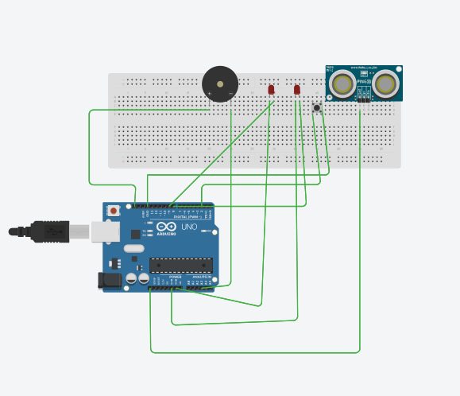

Figure: basic stimulation without gps module (tinker cad)
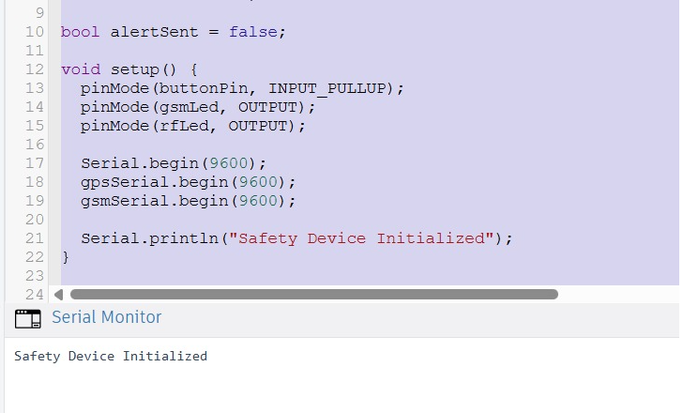
EVALUATION SHEET

Reg.No : URK24CS1121
Name: BLESSY FLORIDA
Course code: 23CS2022
Course Name: Internet of Things
S.No | Rubrics | Maximum Marks | Marks Obtained
1 | Industrial Certification | 5
2 | Problem Statement and Objective | 5
3 | Innovation and Design | 10
4 | Presentation and viva | 5
5 | Report | 5
6 | Project Outcome | 10
Total |  | 40

Signature of the Faculty-in-charge

